**DAILY ONLINE ACTIVITIES SUMMARY**

|  |  |  |  |  |  |  |
| --- | --- | --- | --- | --- | --- | --- |
| **Date:** | | **11 June 2020** | | **Name:** | **KHATHEEJA SAFREENA.** | |
| **Sem & Sec** | | **4th sem, 2nd year** | | **USN:** | **4AL18CS037** | |
| **Online Test Summary** | | | | | | |
| **Subject** | **--------** | | | | | |
| **Max. Marks** | **----** | | **Score** | | **----** | |
| **Certification Course Summary** | | | | | | |
| **Course** | | **CLOUD FOUNDATION.** | | | | |
| **Certificate Provider** | | **Great learning.** | **Duration** | | | **6 hours** |
| **Coding Challenges** | | | | | | |
| **Problem Statement:1 program** | | | | | | |
| **Status: Executed** | | | | | | |
| **Uploaded the report in Github** | | | **Yes** | | | |
| **If yes Repository name** | | | **[http://shafreenasharief / lockdown-coding](http://shafreenasharief / lockdown-coding" \o "http://shafreenasharief / lockdown-coding)**  **[http://shafreenasharief / locked-down--certification-course](http://shafreenasharief / locked-down--certification-course" \o "http://shafreenasharief / locked-down--certification-course)**  **[http://shafreenasharief / Daily\_Report](http://shafreenasharief / Daily_Report" \o "http://shafreenasharief / Daily_Report)** | | | |
| **Uploaded the report in slack** | | | **Yes** | | | |

Certification Course Details: (Attach the snapshot and briefly write the report for the same)

Coding Challenges Details: (Attach the snapshot and briefly write the report for the same)

**CERTIFICATION COURSE SUMMARY:**

Today I continued certificate course on **'CLOUD FOUNDATION**', through **GREAT LEARNING**.The course was scheduled for 6 hrs .I completed 5 modules .I attempted quiz ,which gave me a clear veiw about the topics that were thought and discussed.It consists of 10 modules which also include assessments.

I successfully completed certification course and secured certificate.

**The concept covered in the course are as follows:**

* History and evolution of cloud.
* The classical enterprise.
* Myths of cloud computing.
* Service delivery models.
* Degree of abstraction.
* Cloud attributes.
* Service Offerings.
* Managed Services.
* Subscriptions.
* Cost economics.
* Elasticity.
* Virtualization.
* Evolving to PaaS.
* Next generation virtualization.
* Face-off - VM vs Containers.
* Cloud service taxonomy.
* Overview of infrastructure automation.
* Provisioning process.
* Sample cloud architecture - How it all comes together?
* Concerns.

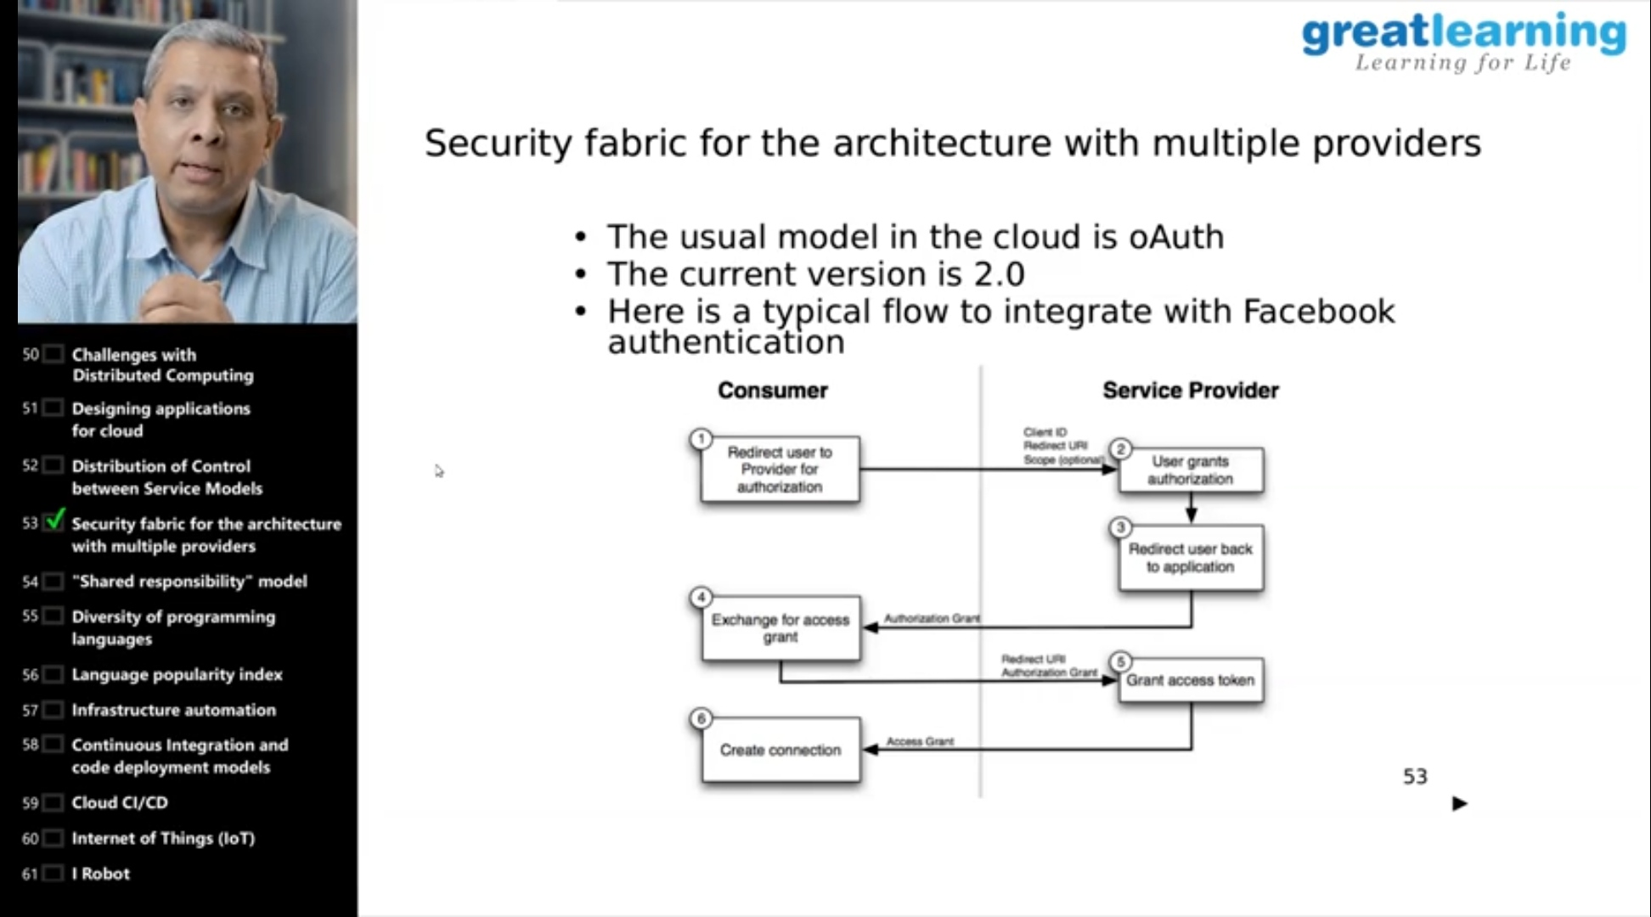

* **There is the snapshot of the certificate.**

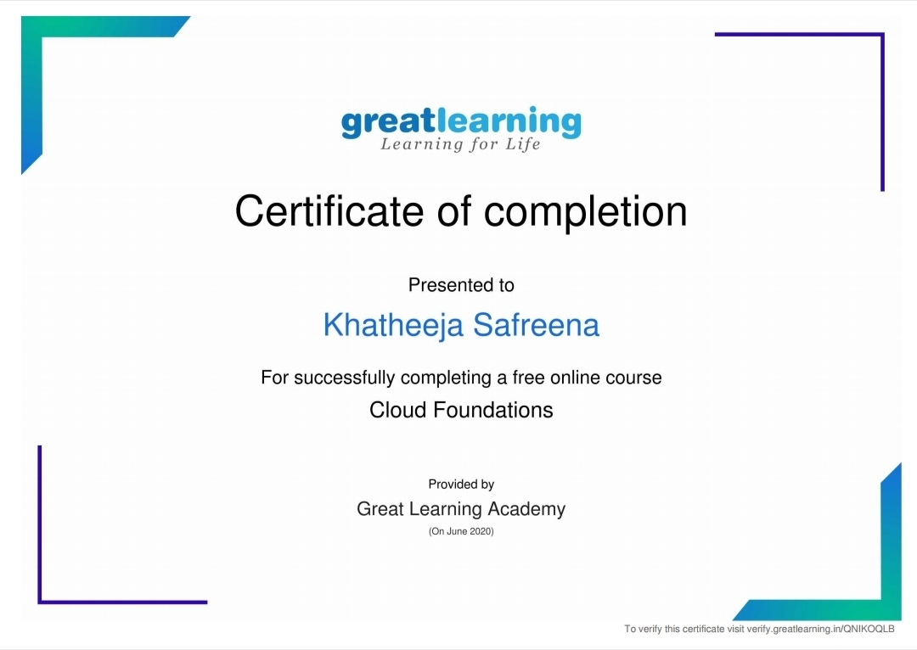

**CODING CHALLENGES:**

Today I solved 1 coding challenge,

**1.Write a Java Program to Segregate Even and Odd numbers**

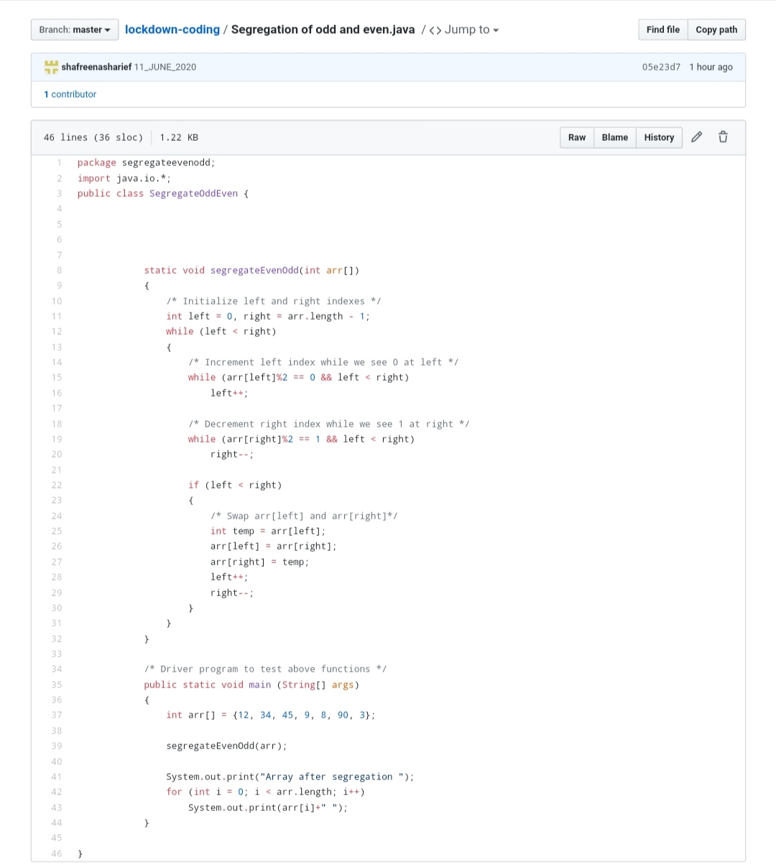

**SOLUTION** : I have uploaded the solution of the above 3 coding problems in my GitHub repository.

http://shafreenasharief / lockdown-coding

http://shafreenasharief / locked-down--certification-course

http://shafreenasharief / Daily\_Report